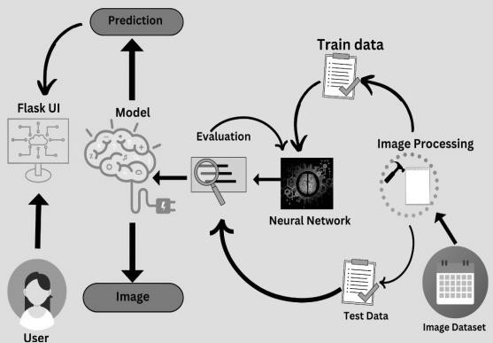

Project Design Phase-II Technology Stack (Architecture & Stack)

Date | 10/11/22
Team ID | PNT2022TMID12678
Project Name | Project - Real time communication system powered by AI for specially abled
Maximum Marks | 4 Marks

Technical Architecture:
The Deliverable shall include the architectural diagram as below and the information as per the table1 & table 2

Table-1 : Components & Technologies:

S.No | Component | Description | Technology
1. | User Interface | How user interacts with application e.g. Flask UI, Mobile App, image etc. | HTML, CSS, Javascript ,python etc.
2. | Application Logic-1 | Logic for a process in the application | Python ,Jupyter,colab
3. | Application Logic-2 | Logic for a process in the application | IBM Watson STT service
4. | Application Logic-3 | Logic for a process in the application | IBM Watson Assistant
5. | Dataset | Sample images etc. | Python,numpy,pandas etc.
6. | Model | Prediction of sample images | CNN model etc.
7. | File Storage | Storing the Predicted images | Google Colab
8. | External API-1 | Purpose of External API used in the application | Tessract,Numpy
9. | External API-2 | Purpose of External API used in the application | NN model
10. | Machine Learning Model | Purpose of Machine Learning Model | Object Recognition Model, etc.
11. | Infrastructure | Google Colab,Jupyter notebook,etc | Keras,Pytessract,Python, etc.

Table-2: Application Characteristics:

S.No | Characteristics | Description | Technology
1. | Open Source Notebook | Jupyter Notebook,Google colab,keras,Tessarct,etc | Image Reading,Image detection
2. | Security Implementations | Image willl be secure and not optimized | e.g. Pixels, color recongnization,etc
3. | Scalable Architecture | Reading the image and training and testing the moodel and predict the output | CNN model
4. | Availability | All applications are open sources available for free  to use | Jupyter Notebbok,Keras,Google Colab
5. | Performance | The performance is good and can predict as much as fast by using the application. | Google colab

References:
https://scholar.google.com/scholar?as_q=Learning+IoT+in+Edge%3A+Deep+Learning+for+the+Internet+of+Things+with+Edge+Computing &as_occt=title&hl=en&as_sdt=0%2C31
https://scholar.google.com/scholar?as_q=When+Edge+Meets+Learning%3A+Adaptive+Control+for+Resource+Constrained+Distributed+M achine+Learning&as_occt=title&hl=en&as_sdt=0%2C31
https://scholar.google.com/scholar?as_q=Unified+Architecture+for+Machine+Learning+in+5G+and+Future+Networks&as_occt=title&hl=en &as_sdt=0%2C31

